AC18Pro PTZ IP Camera Manual
[Part 1: Connect and manage cameras using mobile APP]
Please go google play or Apple store download mobile APP,the name is AC18Pro and install it into your mobile phone
The first time you run the APP, you need to register an account. You can use your email or mobile phone number to register an account, and then use the registered account to log in to the APP.
[1], Configure the camera using WIFI
1. If your camera has WIFI function. Before connecting the power adapter of the camera, please make sure that the LAN port of the camera is not connected to the Ethernet cable (if you have connected it, please disconnect it and press the reset button for 5 seconds to restore the camera to factory settings). After connecting the power, wait 10 seconds.
2. Before using the mobile APP to configure the camera, please connect your mobile phone to your WIFI router via WIFI.
3. Open the APP and click the Add button to add a camera (as shown in Figure 1). And select WIFI (as shown in Figure2), the software will automatically obtain the WIFI of the mobile phone, and please enter the WIFI password (the WIFI connection password of the wireless router). Click Next (as shown in Figure 3)
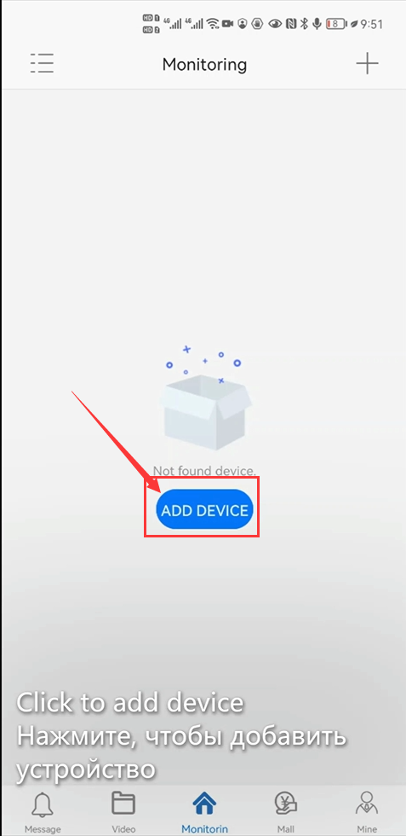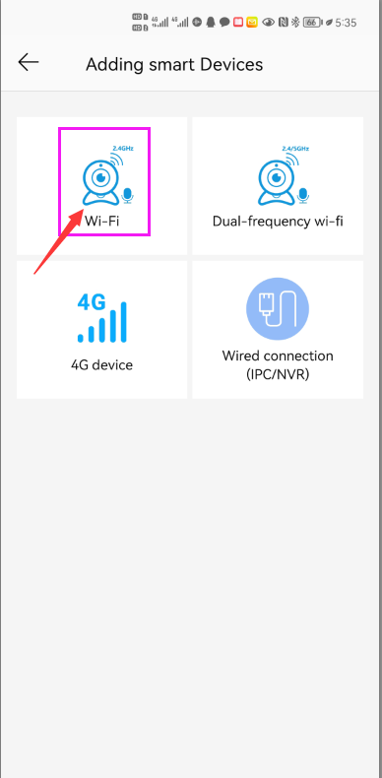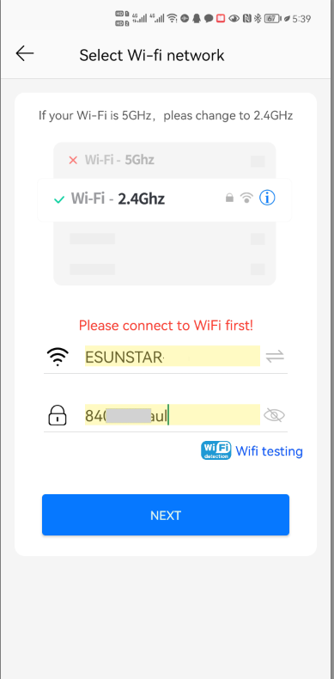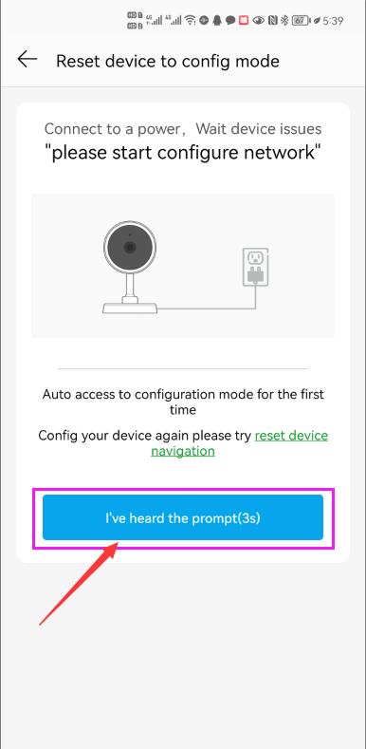
1 2 3 4
After entering the interface of Figure 4, wait for a few seconds, the APP will automatically enter the interface of Figure 5, and the camera will start to match the code through sound waves. When you hear a "di" on the phone, it means that the camera is successfully connected to your wireless router via WIFI (as shown in Figure 6). If your camera does not have a microphone and a speaker at the same time, the sound wave code matching cannot be completed, but you can also add the camera after aligning the QR code on the phone screen with the camera lens. Click the camera on Figure 7, and you will enter the camera's monitoring and management interface (as shown in Figure 8). The camera has been added successfully.
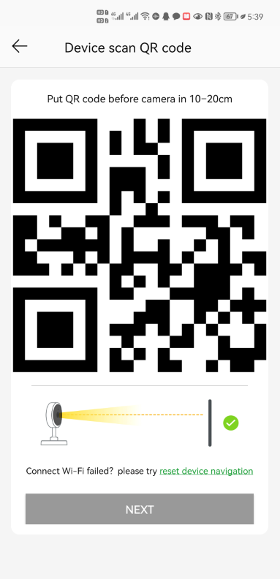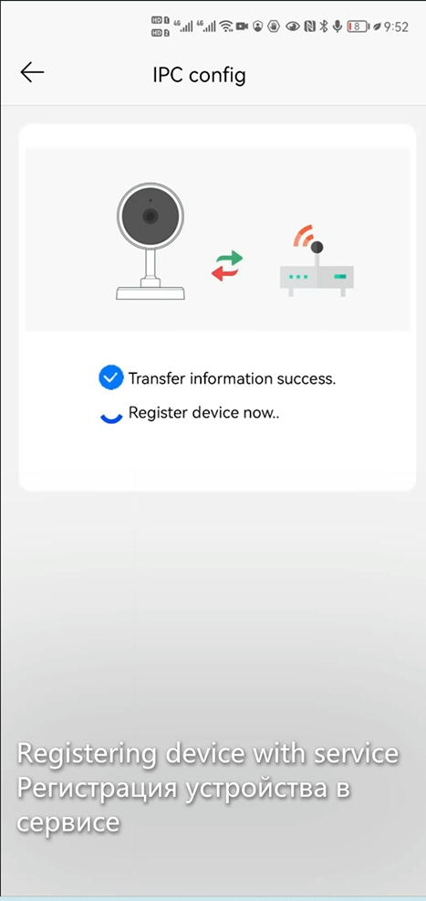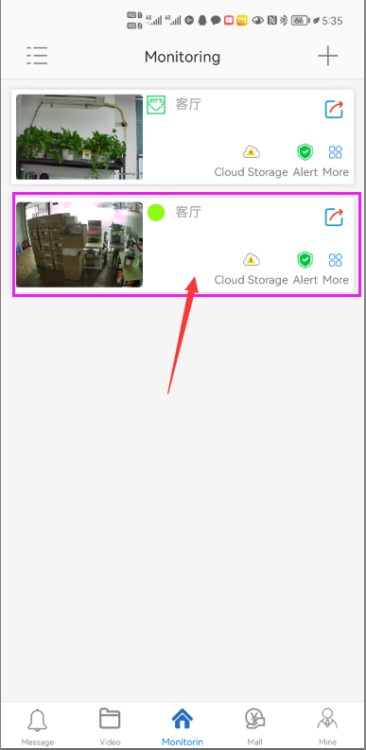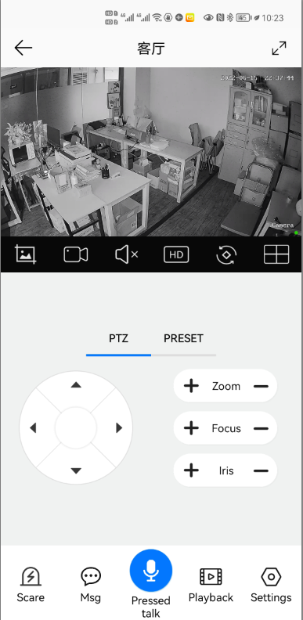
5 6 7 8

[2], Add a camera by scanning a QR code
If your camera does not have WIFI function, please connect the ethernet cable to your switch/router and connect the power adapter. Select "Wired connection camera", as shown in Figure 9, enter the interface of scanning the QR code to add a camera, point the mobile phone at the QR code on the camera body to scan (as shown in Figure 10), after scanning is successful, please provide your Customize a name for the camera, and click "BIND IT" to complete the addition (as shown in Figure 12)
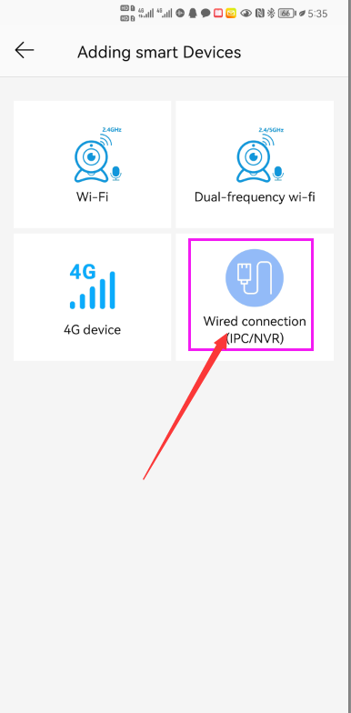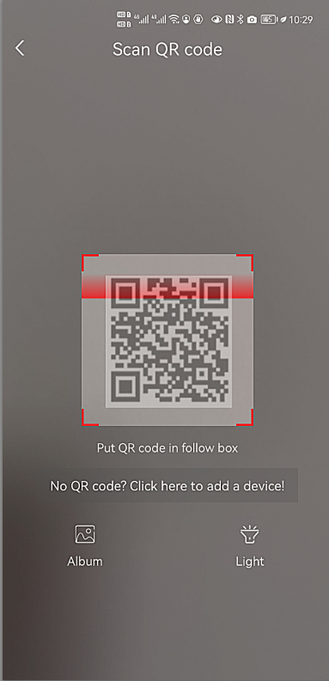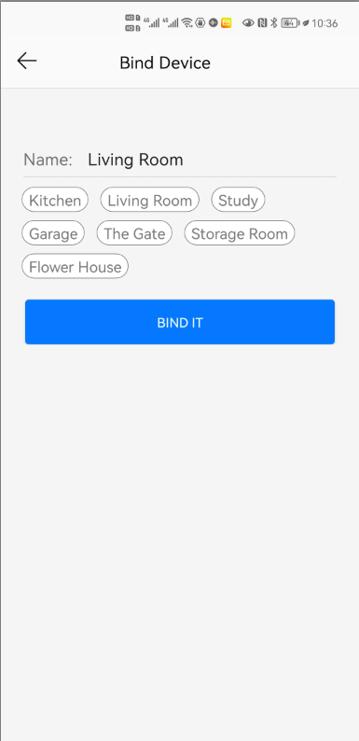
9 10 11 12
[3], Add cameras via LAN connection
If the QR code cannot be found on the camera, you can click "Click here to add a device" to add the camera through the LAN search (as shown in Figure 12), enter the search page, and the APP will automatically search for the camera, as shown in Figure 13 display, and then click the camera to complete the addition.
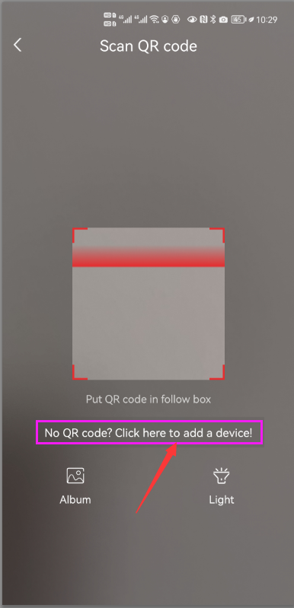
13 14 15 16

[4],How to Turn on/off auto humanoid Tracking
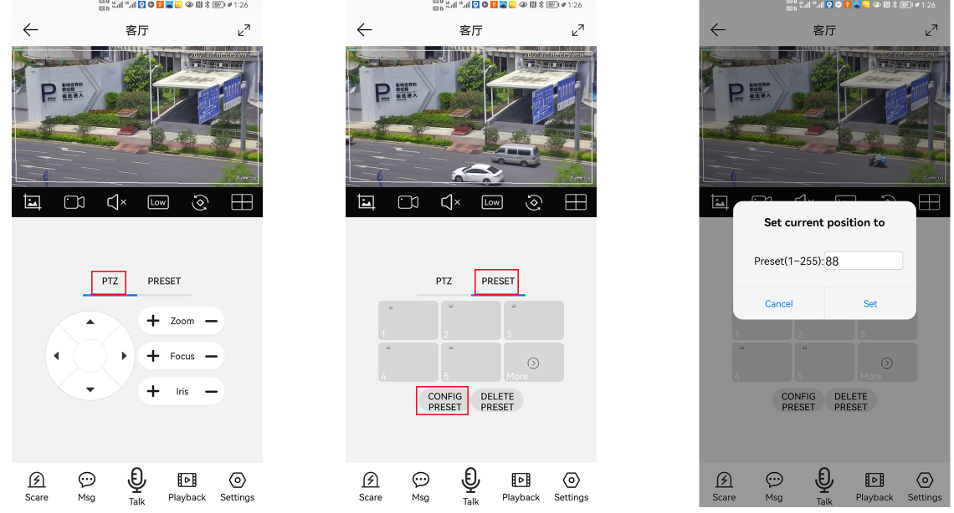
1 2 3
1,Control the PTZ button to rotate the camera to your desired position (set a Return position)
2. Switch the PTZ control interface to the preset position setting interface.
3,Input 88,Then click “Set” button.The tracking return position(Home position) set successfully
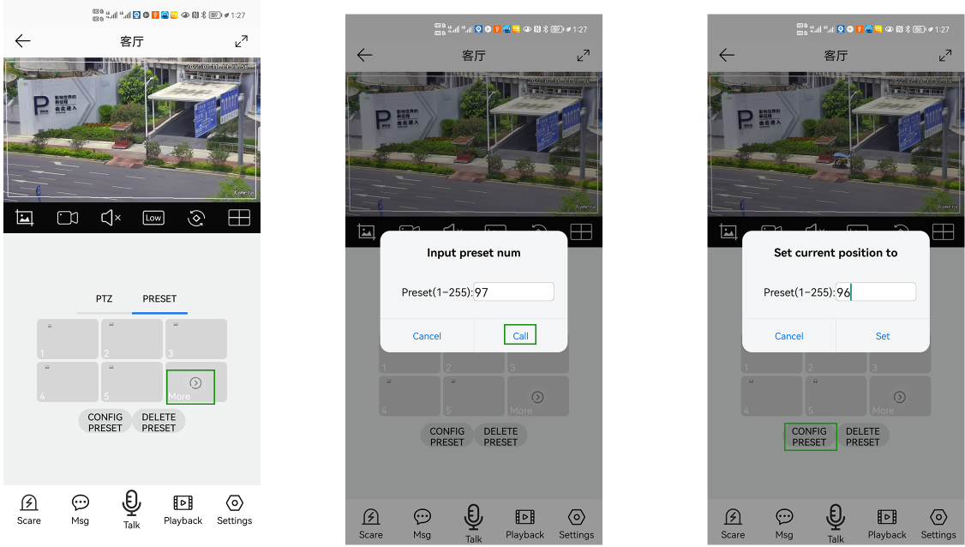
4 5 6
4,Click "More" to enter the preset Call interface
5,Input 97 and click”Call”,The camera will auto turn one humanoid Tracking
6,Click the "config preset" button to enter the preset set interface. Enter 96, then click "Set", the tracking will be turned off.
7,Cruise tracking:
Before turning on tracking, you need to set the camera's cruise point in advance. A maximum of 16 preset points can be set. These cruise points are the few locations you want to monitor. The camera will cruise back and forth between these locations to find a tracking target. Really made a camera monitors multiple angles of demand. Turn on cruise trackingfunction,The camera will cycle moving through the preset cruise points. When the person is detected, the camera will turn on the tracking. After the tracking is completed, the camera automatically resumes the cruise until the next time the person is detected, the tracking is turned on again
Set 1,2,3,4….max 16 preset position,Then call 98th preset camera will auto turn on cruise tracking. Setting method: [98]+[Call] for turn on cruise
Part 2: Add and manage cameras using PC software
[1],Install search tool on your PC
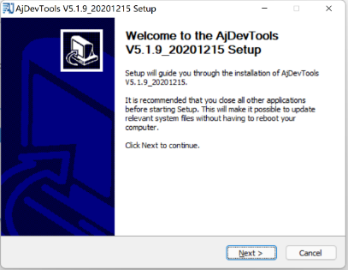
1,Run” AjDevTools_V5.1.9_20201215.exe” and complete the installation
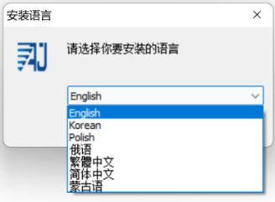
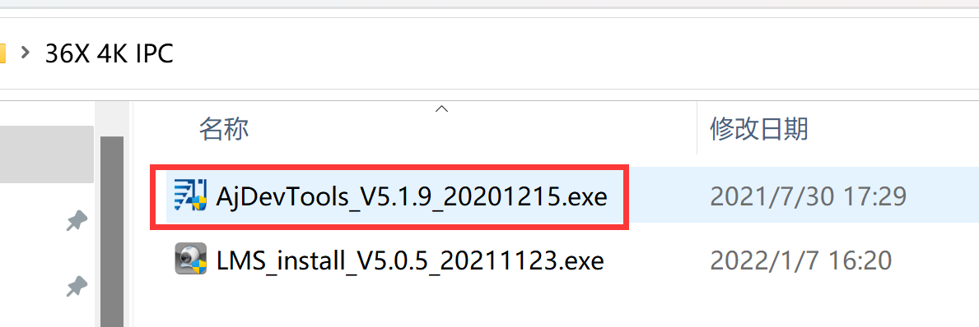

1 2
3
2, Run the software, as shown below（4）
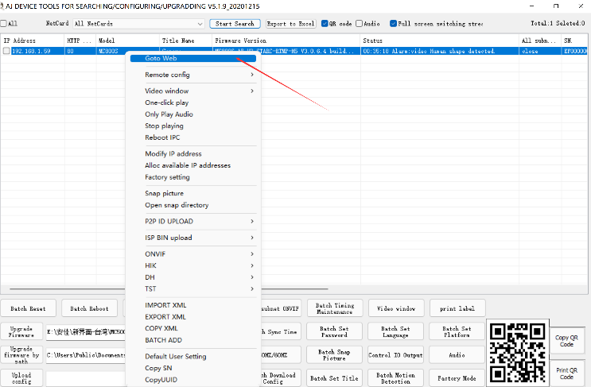
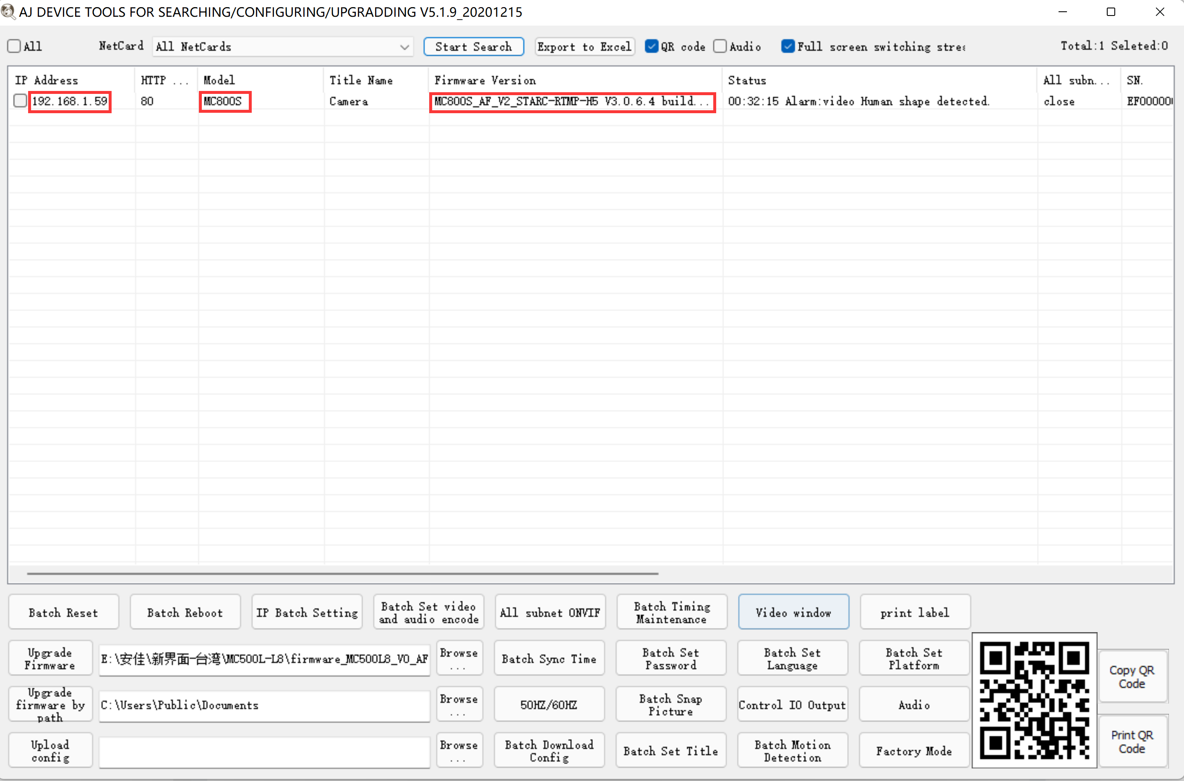
4 5
3, Here you can modify the IP address of the camera, upgrade the firmware and other parameter settings. Right-click on the IP address to open the camera with a browser, as shown in the figure 5.

4,Enter the browser login interface, login user name: admin, password: 123456, as shown in the following figure (if the browser prompts you to download and install the plug-in, please download and install it): Then click login ，as shown in the figure 7
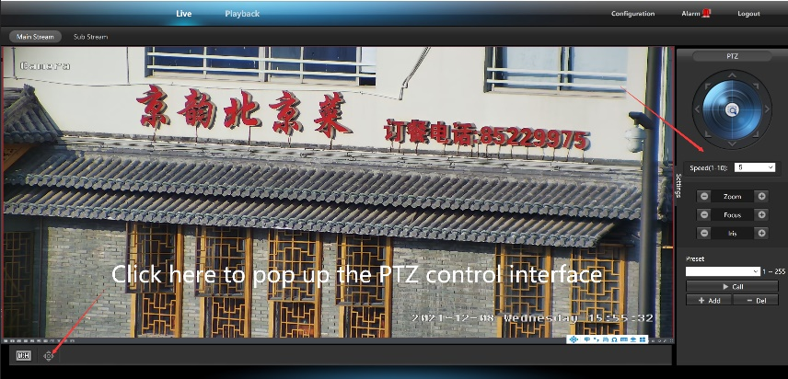
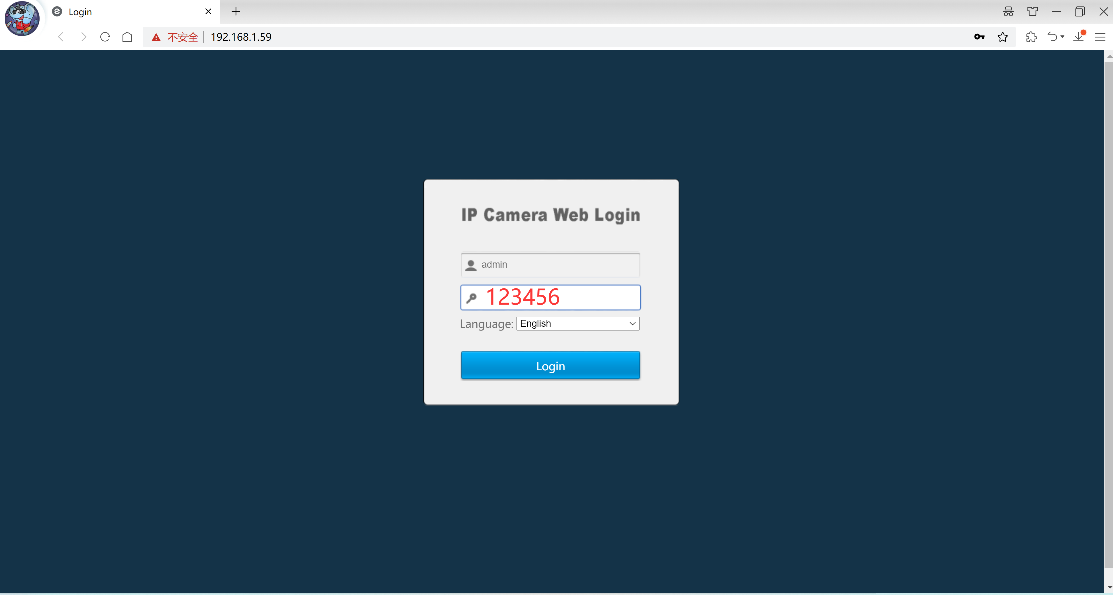
6 7
[2],Use PC software to search and add cameras
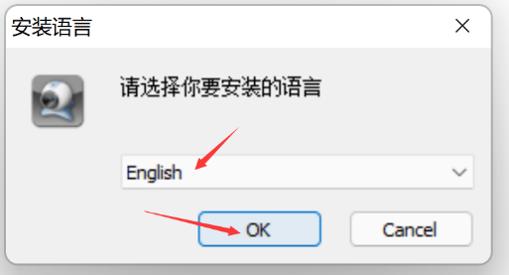
1，Install the LMS computer software.
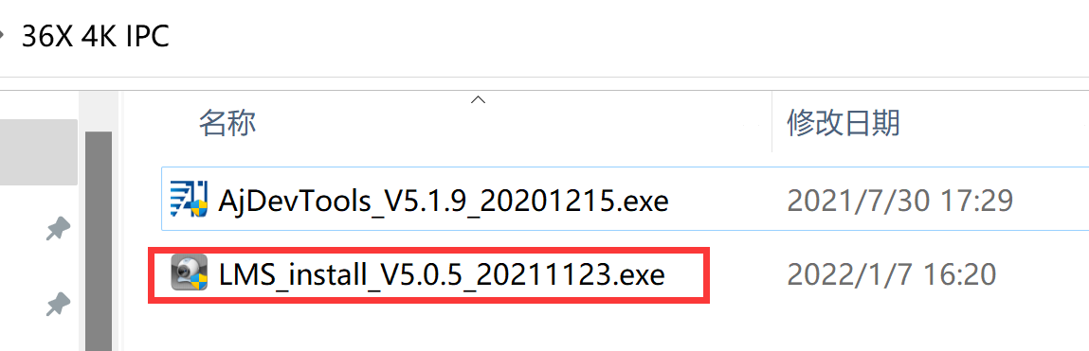
8 9
The software supports English, Simplified Chinese and Traditional Chinese (if you want to support other languages, we can provide you with language packs, you can translate into the language you want, and then we can provide you with software customization)
2，Follow the prompts to complete the software installation
3, Run the LMS software:user:admin,password:123456
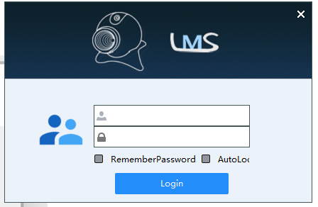
Click LOGIN to log in to the software
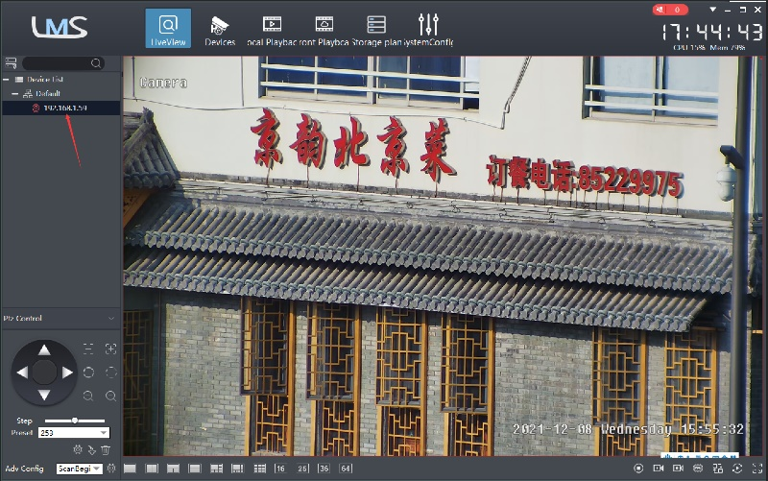
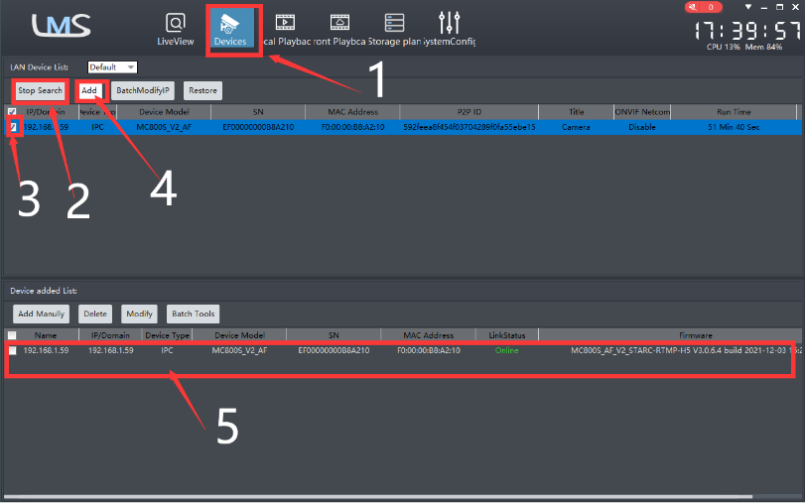

10 11
4. Search and add cameras.Click “Devices>””Start Search”>click“3”>add >successfully added，as shown in the figure 10
Then click” 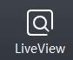” go to Liveview, as shown in the figure 11
Double click on the IP address and the video will automatically appear in the video box on the right.
[3], Preview and control cameras with AC18PRO PC software
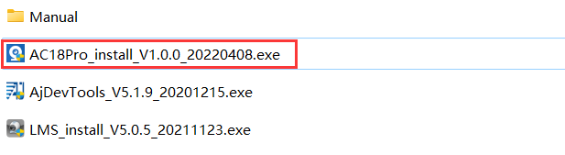
1, Double-click the AC18PRO software in the directory, follow the prompts to complete the installation of the camera, and then run the camera.

2,run and login AC18PRO,
The username and password here are the account you registered for the first time on your mobile phone.
Click login button go to AC18PRO
You will see all the cameras under your account, you can preview the
cameras and view the video playback in this way
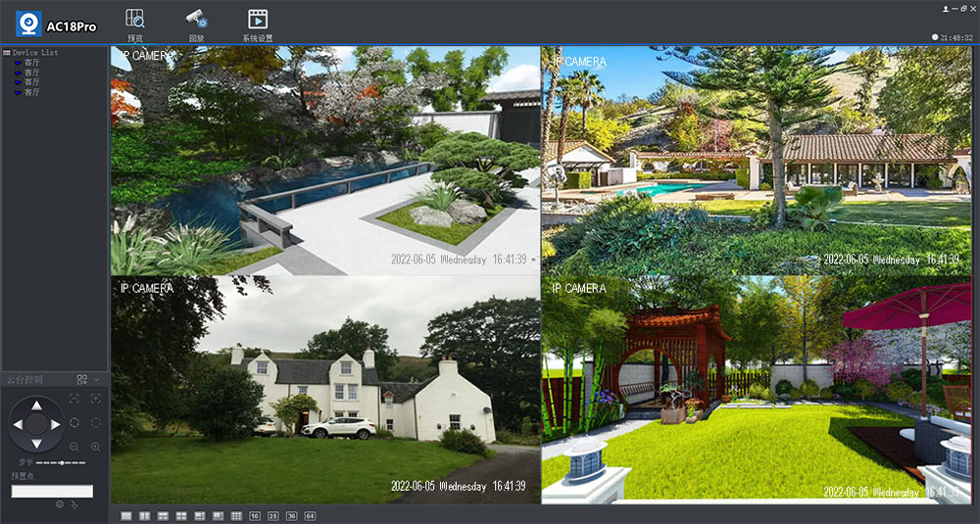
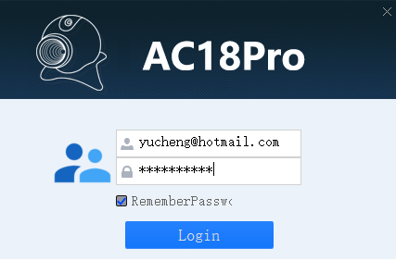

Part 3 【Function Operation and Description】
Professional name explanation: Set/Add:set preset, Call:Call preset, [N]+[set]=Enter N first and then click SET.“+”=Then
1,Preset settings
Rotate the camera to the position you want, then set this position to “N” preset
[N] +[SET] ,N is preset point, 1-255 number can be optional (But the command Preset isn’t include). Set= set preset
2.Call preset( need set the corresponding preset point) : [N]+[CALL]
N for preset point, 1-255 number can be optional, camera can move to preset point after call, Zoom, focus and aperture lens will automatically change to preset parameters , camera preset display on the monitor.
3.Delete all preset point: [100] +[CALL] ,Call no.100 preset, clear the all preset :[1]+[0]+[0]+[CALL] .
4.Auto scan(Horizontal rotation)
[120]+[CALL], call No.120 ,the lever of 360 /355 degree clockwise automatic scanning
Modify speed of Auto scan :
[121]+[Set] +[N]+[Set]; (N=1-10; N represents scan speed percentage,default is 8=80%)
If you wanto to change speed of auto scan to 50%; Setting method: [121]+[Set] +[5]+[Set]
5,The inspection group programming
Before you start cruising, you first need to set the preset position in the cruise path.Please refer to “ 3.Preset settings”
[101]+[CALL] for Open the first Cruise of 1-16 to scan ；[102]+[CALL] for Open second Cruise of 17-32 to scan
[103]+[CALL] for Open the third Cruise of 33-48 to scan
Modify the stay time of the Cruise:
[123] +[Set] + [N]+[Set]; (N=3-10; N represents the dwell time at each preset,default is 5 seconds)
If you change the dwell time to 10 seconds. Setting method:[123]+[Set] + [10]+[Set]
Modify speed of the Cruise:[115]+[Set] + [N]+[Set]; (N=1-10; N represents Cruising speed percentage,default is 8=80%)
If you change speed of the Cruise to 40%; Setting method:[115]+[Set] + [4]+[Set]
6,Left and right limit scan settings
The users can set left and right limit point in the range of the rotation, the speed dome can return scan in setting range [81]+[SET]: left limit; [82]+[SET]: right limit, [83]+[CALL]: start right and left limit scan
Modify the speed of right and left limit scan:
- +[SET]+[N] +[SET]; (N=1-10; N represents Cruising speed percentage,default is 5=50%)
If you change speed of the limit scan to 100%; Setting method:[141]+[Set] + [10]+[Set]
7.Idle action settings:The camera performs a certain function in standby mode
[130]+[Call]: Open Idle position Set；[130]+[set]:OFF Idle position set
Idle position setting:[131]+[Set]+[N]+[Call],
N=Function preset;When N=98, the camera Open the first Cruise of 1-16 to scan function. Setting method:[131]+[SET]+ [98]+[CALL]
Set the time when the idle action start: [132]+[set]+[N]+[SET]; (N=1-30; N represents Idle time,default is 5 minutes)
8, Home/return position setting:The position where the camera returns when the camera is in standby mode
Set watch position:Rotate the camera to the position you want, then [125]+[SET] , and the current position is the watch position, and turn this feature on. When the camera is in standby, the camera will automatically rotate to this position.
Setting method:[125]+[SET]
Delete watch position: [125]+[CALL] for delete watch position；Setting method:[125]+[CALL]
Set the watch start time: [126]+[set]+ [N]+[SET] ;(N=1-10 minutes; N represents start time time,default is 5 minutes)
9.Restore factory settings
[106]+[Call]+[64]+[CALL] for restore PTZ speed dome to factory setting；Setting method:[106]+[Call]+[64]+[CALL]
10.IR light settings
1) The brightness settings for all lamp: [122]+ [set] +[ N]+[ set]; (N=1-10; default is 8=80%). Setting method: [122]+[SET]+[N]+[SET]
- An infrared detection threshold setting:
[91]+[SET]+[N]+[SETt] (N=1-10;N represents Ambient light brightness,1-10=0.1Lux-1LUX )
Setting method: [91]+[preset]+[N]+[preset]; If you want the IR light to turn on at 0.5LUX, Setting method: [91]+[preset]+[5]+[SET]
3) IR light auto mode:Infrared light is controlled by changes in light brightness; Setting method: [137]+[Call]
4）IR light Forced on mode:The infrared light is always on, day or night, and the camera stays in night mode.
Setting method: [138]+[Call]
- IR light Forced to close. The infrared light is always off during the day or night, and the camera is in day mode.
Setting method: [139]+[Call]
Part4【Common functions operating Express 】
Function name | Explanation | Preset | Call | Set
Set return position | position of the camera return after the end of the tracking | 88 |  | √
Turn OFF auto tracking | Turn off auto tracking (default) | 96 |  | √
Turn On auto tracking | Turn On auto tracking | 97 | √
Turn on cruise tracking | Turn on some preset position cruise tracking | 98 | √
Tracking end Waiting time | 153+Set+N+Set,N=1-10 seconds ,default N=3 Seconds | 153 |  | √
Re- tracking time when manual control end | 158+Set+N+Set, N=1-10 minutes,Default N=5 minutes | 158 |  | √
Re- cruise tracking time when manual control end | 159+Set+N+Set, N=1-10 minutes,Default N=5 minutes | 159 |  | √
Level track speed set | 150+Set +N+Set, N=1-100% MAX speed=45︒/Sencond | 150 |  | √
Vertical track speed set | 151+Set +N+Set , N=1-100% MAX speed=45︒/Sencond | 151 |  | √
Tracking zoom control | 95+set for turn on ZOOM(default);95+call for turn off Zoom when camera tracking | 95 | √ | √
IR light auto mode | Infrared light is controlled by changes in light brightness | 137 | √
IR light Forced on mode | IR light is always on, and the camera stays in night mode. | 138 | √
IR light Forced to close | IR light is always off during , and the camera is in day mode | 139 | √
IR detection threshold setting | 91+Set+ N+Set; (N=1-10;N represents Ambient light brightness,1-10=0.1Lux-1LUX ) | 91 |  | √
Dipped beam and high beam switch | The user can arbitrarily set the near light and the remote light to switch position. | 92 | √
Full IR open | The user can arbitrarily set the position where the near light and the far light are simultaneously turned on. | 93 | √
IR brightness adjustment | brightness set for all IR: 122 + set +N+Set; (N=1-10; default is 8=80%) | 122 |  | √
Auto scan(pan) | the lever of 360 /355 degree clockwise automatic scanning | 120 | √
Modify speed of Auto scan | 121+set +N+Set;(N=1-10; N represents scan speed percentage,default is 8=80%) | 121 |  | √
Open the first cruise | Open the cruise | 101 | √
Set cruise speed | 115+Set+N+Set; (N=1-10; N represents Cruising speed percentage,default is 8=80%) | 150 |  | √
Modify the stay time of the Cruise | 123+set+ N+Set; (N=3-10; N represents the dwell time at each preset,default is 5 seconds) | 123 |  | √
Left limit | Set Left limit | 81 |  | √
Right limit | Set Right limit | 82 |  | √
Open limit scan | Open limit scan | 83 | √
Modify the speed limit scan | Modify the speed of right and left limit scan: 141+set +N+Set; (N=1-10; N represents Cruising speed percentage,default is 5=50%) | 141 |  | √
Set and open the Home position | Rotate the camera to the position you want, then set 125+ Set, and the current position is the Home position, and turn this feature on. When the camera is in standby, the camera will automatically rotate to this position | 125 |  | √
Delete watch position |  | 125 | √
Set the watch start time | 126+set +N+Set; (N=1-10 ; N represents start time,default is 5 minutes) | 126 |  | √
Open Idle action | Open Idle action | 130 | √
Close Idle action | Close Idle action | 130 |  | √
Idle action Setting | 131+Set + N+Call ,N=Function preset | 131 |  | √
Set the time when the idle action starts | Set the time when the idle action starts: 132+set+ N+Set (N=1-30; N represents Idle time,default is 5 minutes) | 132 |  | √
Open Lens focal length and speed match | PTZ speed, lens zoom automatic matching is enabled (default is on) | 108 | √
Len and speed match | Close Lens focal length and speed match,Turn off automatic matching | 108 |  | √
Focus mode setting | 77+Set+N+,CALL; N=1:AF ZOOM PUSH MODE;N=2:AF PTZ PUSH MODE N=3:AF AUTO MODE(Auto Mode) | 77 |  | √
Focus distance setting | 78+Set+N+Call, N=1 1 for 1.5M ,N=2 for 3M, N=33 for 6M | 78 |  | √
Delete all preset point | Delete all preset point | 100 | √
pan/tilt correction | 107+Set+ 64+Call | 107 | √
Restore factory settings | 106+Call+64+Call | 106 | √

